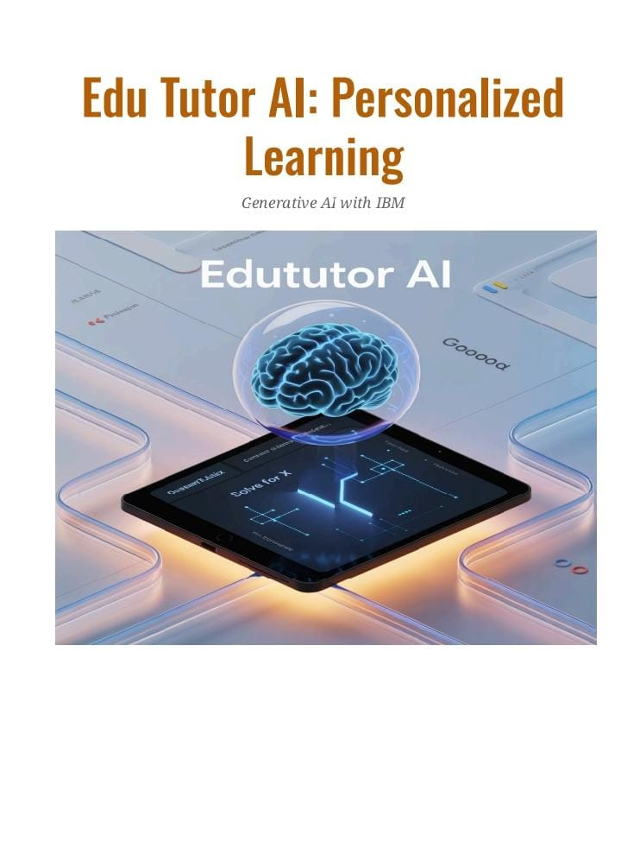

EDU TUTOR AI

**TEAM MEMBERS**

* Srihari M
* Rajpandian K C
* Gokularamanan R
* Aadhi k

1. PROJECT OVERVIEW

PURPOSE:

Edututor is an intelligent e-learning assistant designed to personalize education for students and support teachers with smart tools. By leveraging AI and interactive modules, Edututor enhances learning experiences through adaptive lessons, real-time feedback, and engaging quizzes. For educators, it provides analytics dashboards, automated grading support, and resource recommendations. Ultimately, Edututor bridges technology and education to make learning more effective, inclusive, and accessible.

FEATURES:

**Conversational Learning:** Students interact using natural language to ask questions, clarify

doubts, and receive explanations.

**Personalized Lessons:** Adaptive content tailored to student performance and learning speed.

**Quiz & Assessment Generator:** Automatic creation of quizzes with instant feedback.

**Analytics Dashboard:** Provides teachers insights into student progress and areas needing

improvement.

**Resource Recommendation:** Suggests learning materials, videos, and practice exercises.

**Collaborative Tools:** Group projects and peer-to-peer interaction support.

**2. ARCHITECTURES**

**Frontend (React/Streamlit):** Provides an interactive UI for students and teachers.

**Backend(FastAPI/Django):** Handles APIs for quizzes, analytics, and recommendations.

**AI Models:** Powers

personalization, grading, and adaptive learning using NLP and ML.

**Database:** Stores user progress, resources, and activity logs securely.

**3. SETUP INSTRUCTIONS**

Choose a IBM Granite Model from Hugging Face.

Using “granite 3.2-instruct” .

Running Application in Google collab.

**4 .RUNNING**

Start backend server ➢ Launch frontend dashboard ➢ Register/login as student or teacher ➢

Upload/assign resources and quizzes ➢ Track progress via analytics dashboard.

**5. APPLICATIONS**

**• Student-friendly dashboard**

**• AI-powered doubt assistant**

**• Smart quiz and test creation**

**• Analytics for progress tracking**

**6. FUTURE ENHANCEMENTS**

**• Multilingual support for global education**

**• Integration with AR/VR for immersive learning**

**• Adaptive learning paths using AI-driven insights**

**\* Teacher support with automated grading and content suggestion**

7. CODE SCREENSHOTS

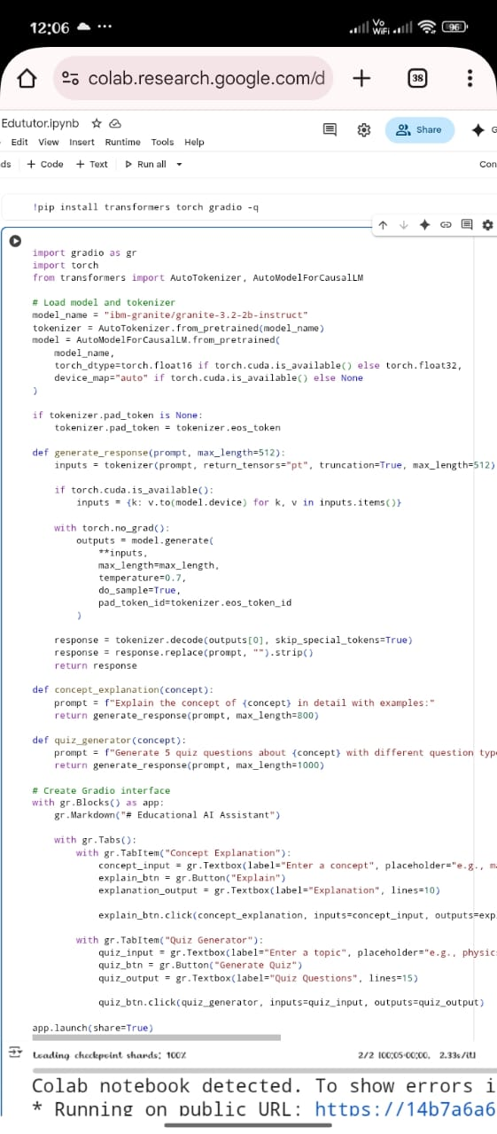

**8. OUTPUT**

